Java callout

1) Add the Javacallout-spi.jar to the project as an external JAR. Make sure the JRE/JDK version used is 1.6 as it is the only version Apigee supports.

Add Java callout spi jar:
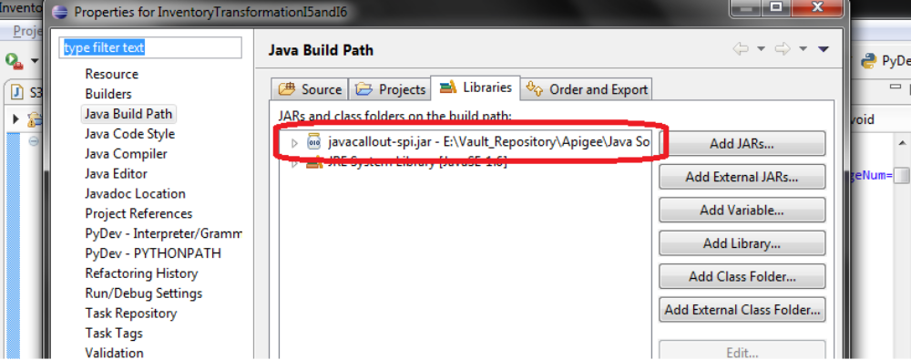

2) Import the required packages into the project. Also, implement the JavaCalloutTask interface, for the class required to be executed on the Java callout.

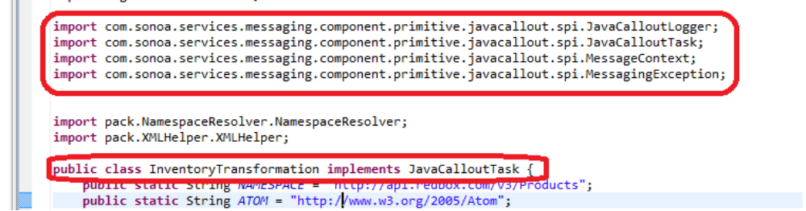
Implement JavaCalloutTask interface:

3) Provide the implementation for the execute and isBlockingTask methods in the class.

Execute method is called by the Apigee gateway when the Java callout is invoked.
IsBlockingTask, determines whether the task is blocking or not. We leave it at the default implementation, which returns a false value.
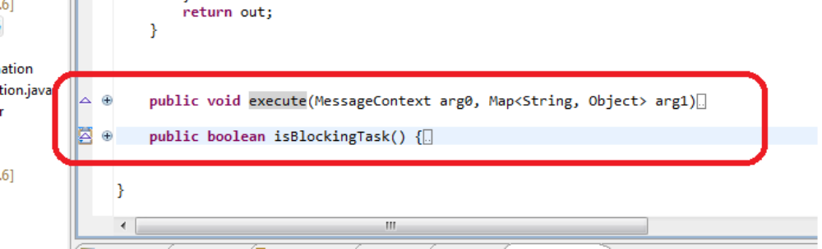
Implementation of execute and isBlockingTask methods:

4) Access the required context variables from the message context object.
Variables like query params, message params and other flow variables can be accessed by means of the MessageContext object.

Access the context variables from MessageContext object:
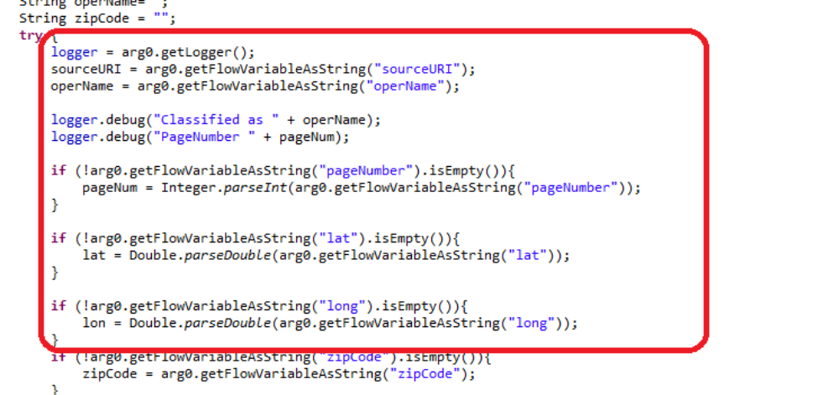

5) Build the project and create a JAR of the same.

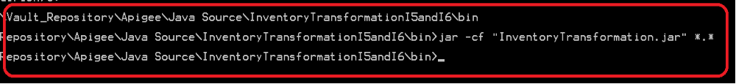
6) Add the Jar on the required policy
Create a Jar Directory where the JAR files will be placed
Add the JAR file
Give the fully qualified class name
Select the Java Callout Resource created on the gateway

Java Callout Policy on Apigee:
